Code and its result

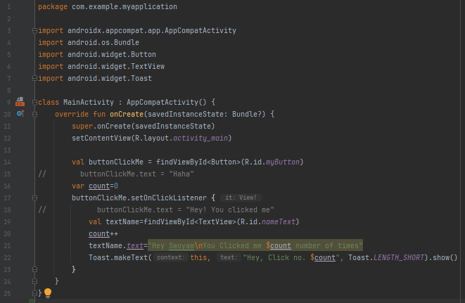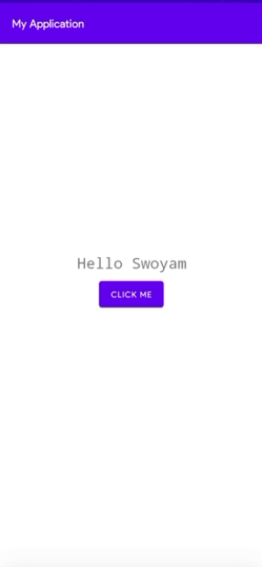

  
The above loads the content view made from the XML File

  
In the XML file, we have give the button and id of **myButton**, now we are creating a connection link between the **Kotlin Code** and the button through the given code. All the further edits with the button can be done through code with the help of the **Connecting Variable**

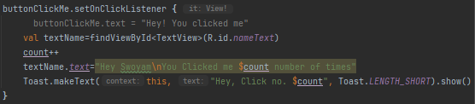  
Here, we’ve used the **Connecting Variable** to define and declare the actions that should be done when the user clicks the button. It is also a great example of how we can use **Connecting Variables** for controlling the Button and its uses

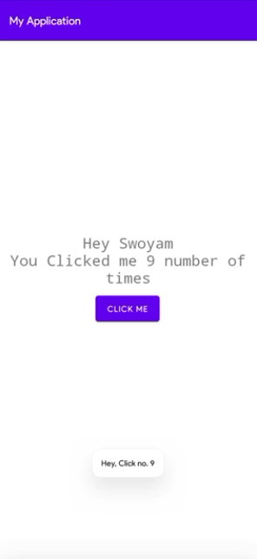  
This is an example of creating a toast. Refer to the code to analyze how we are controlling the text that is to be shown in the toast